EX No 2:
Design a UI where users recall visual elements (e.g., icons or text chunks). Evaluate the effect of chunking on user memory.
Figma – How to Setting Up the UI
A. Home Screen (It contains Instruction Page)
Step 1: Create a Frame:
  - In Figma, create a new frame (File → New Frame). Set the size to 1024x768px for a standard desktop view.
  - This will be your Home Screen where users start the task.
Step 2: Add Instructions:
  - Use the Text Tool (T) to add a heading like "Memory Recall Task."
  - Add a smaller body of text with instructions such as:
    - "You will be shown several groups of icons or text. After viewing, recall the items you remember."
  - Use the Text Tool (T) to add more detailed instructions like "You will have 5 seconds to view the items. Then, recall them in the next screen."
Step 3: Start Button:
  - Create a button at the bottom of the screen. To do this:
    - Draw a Rectangle (R) for the button.
    - Use the Text Tool (T) to add “Start.”
    - Style the button (color, border radius) to make it stand out.
    - Use Figma’s Prototyping Tools (top bar → Prototype) to link this button to the next screen (Chunking Phase).
    - You can also use interactive components like hover effects for more realism.
Sample Output of (Step A) Looks like this (Need not to be the same)
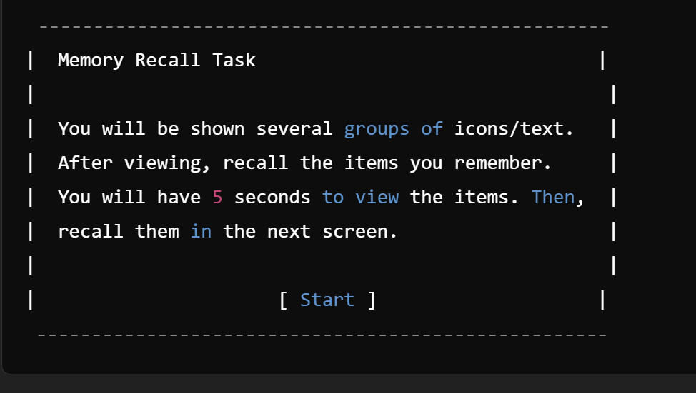

B. Chunking Phase (It Display Chunked Items)
Step 1: Create a New Frame:
  - Create a new frame for the Chunking Phase (the second screen). This frame will display the icons or text.
Step 2: Design Chunked Items:
  - Use icons or text blocks that users will have to recall. If you're using text, it could be short phrases or words. If you're using icons, you can either import them from Figma's resources or draw simple shapes using Figma’s drawing tools.
  - For Chunking with Borders:
    - Group 3-5 icons or text together in a box (use the Rectangle Tool (R)) to visually represent a chunk. You might want to create 3-4 groups.
    - Space these chunks out with some empty space in between them to ensure users can identify each chunk.
  - For Chunking without Borders:
    - Place the elements next to each other without clear separation. This can be done by not using boxes and just visually mixing the items.
Step 3: Set the Viewing Time:
  - Time Simulation: Figma does not have true timers, but you can simulate a fixed time by setting the next screen transition after 5 seconds:
    - Select the entire Frame (Chunking Phase).
    - Under the Prototype tab, link this frame to the next screen (Recall Phase).
    - Set the interaction to “After Delay” and enter 5000ms (5 seconds).
Sample Output of (Step B) Looks like this (Need not to be the same)
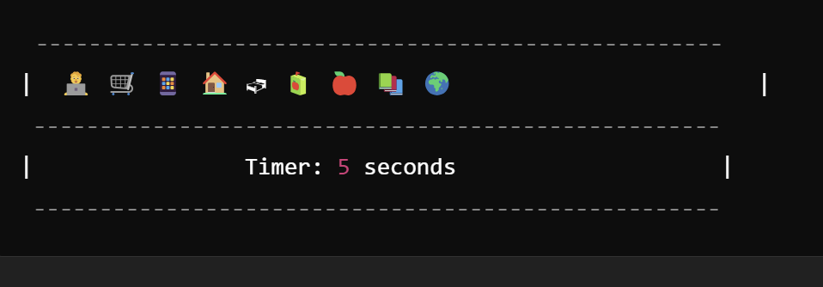

C. Recall Phase
Step 1: Create a New Frame for Recall:
  - This is where the user will recall the items they saw in the previous chunking phase.
Step 2: Recall Input (Multiple-choice or Text Input):
  - Option 1: Multiple-Choice:
    - Create multiple options for the user to select (e.g., 4-5 icons or text options).
    - Use Checkboxes or Radio buttons to allow users to select what they remember.
    - Add a question at the top: "Select the items you remember seeing."
  - Option 2: Text Input:
    - Create Text Input Fields where users can type what they remember. Create 3-5 input fields depending on how many chunks you showed.
    - This can be done by selecting the Text Tool (T), adding a label ("Item 1", "Item 2"), and setting up input boxes.
Step 3: Submit Button:
  - Create a Submit button at the bottom using the Rectangle Tool (R) and adding text like "Submit Recall."
  - Add an interaction to move to the Feedback Screen after submission.
Sample Output of the Visual Appearance of the Recall Phase (Step C) in Figma (Text Input Fields):
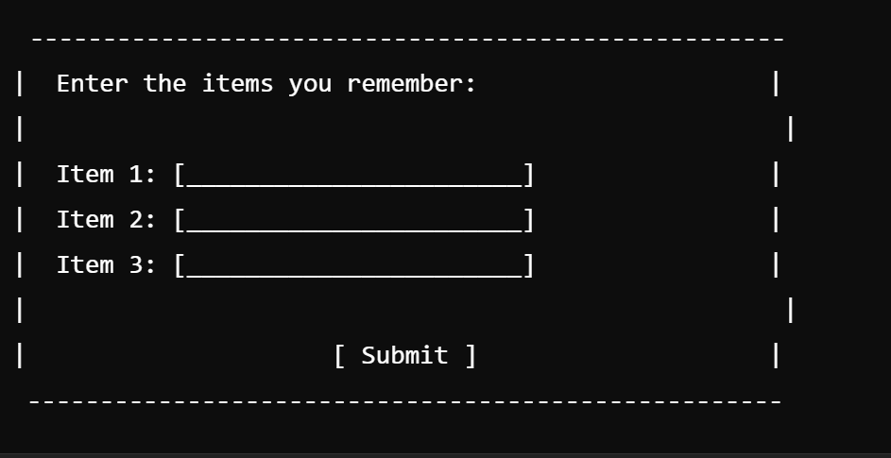
Sample Output of the Visual Appearance of the Recall Phase (Step C) in Figma (Multiple Choice):
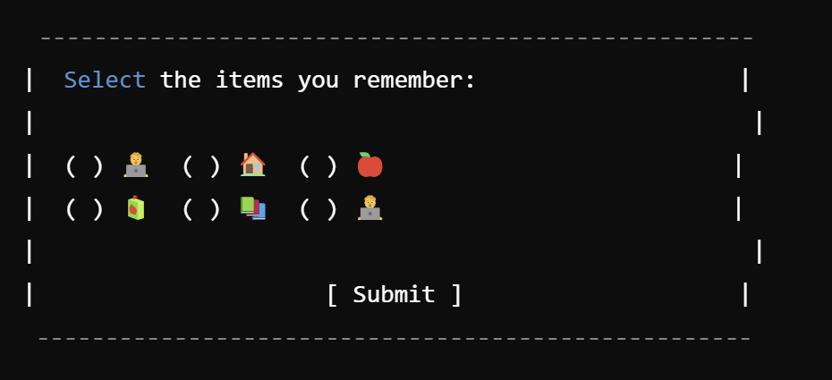

D. Result Screen
- Create a Feedback Screen:
  - After the user submits their recall, provide feedback.
  - Add text like: “You recalled 4/5 items correctly!” or “Good job, you remembered 3 out of 5 items.”
- Analyze:
  - For your experiment, you can vary the chunk size (3 vs. 5 items per chunk) and the chunk type (icons vs. text) across different test sessions to evaluate their impact on recall.
Sample Output of Visual Appearance of the Result Screen in Figma:
